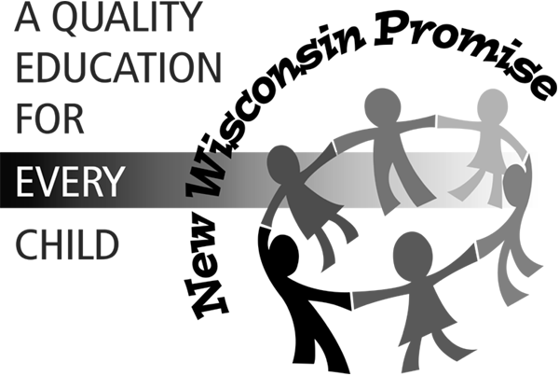 | State of Wisconsin  DEPARTMENT OF PUBLIC INSTRUCTION  State Superintendent’s Council on Special Education

Announcement

Public Forum on
Special Education
in Wisconsin

November 9, 2005

The State Superintendent’s Council on Special Education is pleased to announce that it will hold, as part of its November meeting, a public forum to obtain broad based input on special education. This public forum will be held November 9th from 5:00 to 7:00 PM at the Comfort Inn located at 4822 East Washington, Madison, Wisconsin.

The purpose for this forum is to gather public input on the unique challenges and successes of special education in Wisconsin. Information gathered will be used by the Council in advising the Department of Public Instruction on matters affecting the education of Wisconsin’s children and youth with disabilities. In particular the Council is interested in gathering input on the following topics; however the Council is receptive to hearing about any topic people may wish to comment on.

- IDEA 2004 and State Special Education Law
- Parent Education Needs with Respect to Special Education Law Changes
- Cross Categorical Programming
- Disproportionality Issues in Special Education
- Teacher Preparation; Highly Qualified Teachers

The mission of the Council is to promote the education of children with disabilities by providing broad-based input to the Department of Public Instruction. The Council is comprised of adults with disabilities, parents of children with disabilities, regular and special education teachers, school administrators and school board members, as well as representatives of various agencies that provide services to the school age children and youth with special education needs.

Interested parties are urged to attend, and share their experiences. For more information contact Pat Yahle, Council Chairperson, at (414) 475-8608 or yahlepa@milwaukee.k12.wi.us, or Kirby Lentz, Council Vice-Chairperson, at (608) 782-6480 x237 or kblentz@charter.net.

